Assignment 7 - Savitha Balarajan

**Day 7**

1.     Rank employees by their total sales(Total sales = Total no of orders handled, JOIN employees and orders table)

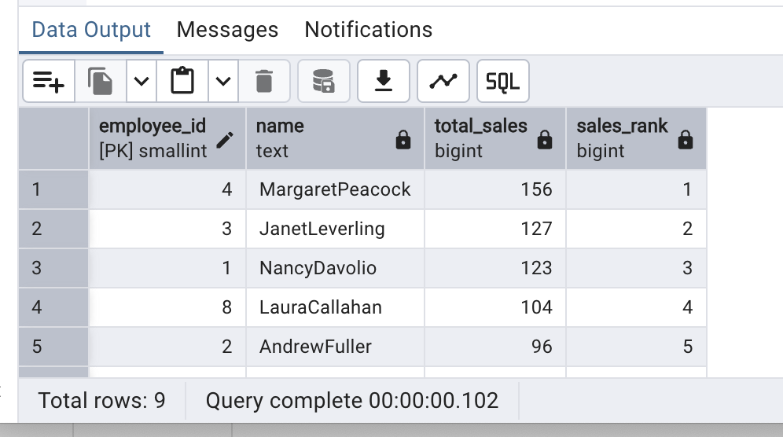

2.      Compare current order's freight with previous and next order for each customer.(Display order_id,  customer_id,  order_date,  freight,Use lead(freight) and lag(freight).

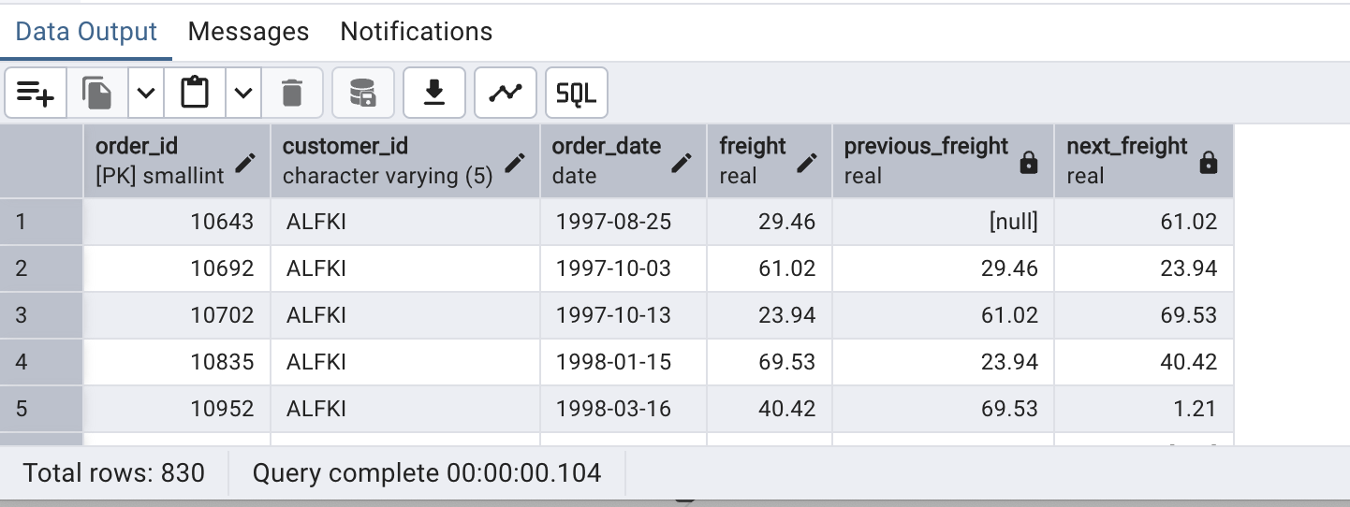

3.     Show products and their price categories, product count in each category, avg price:  (HINT·  Create a CTE which should have price_category definition:WHEN unit_price < 20 THEN 'Low Price' WHEN unit_price < 50 THEN 'Medium Price ELSE 'High Price'.In the main query display: price_category,  product_count in each price_category,  ROUND(AVG(unit_price)::numeric, 2) as avg_price)

